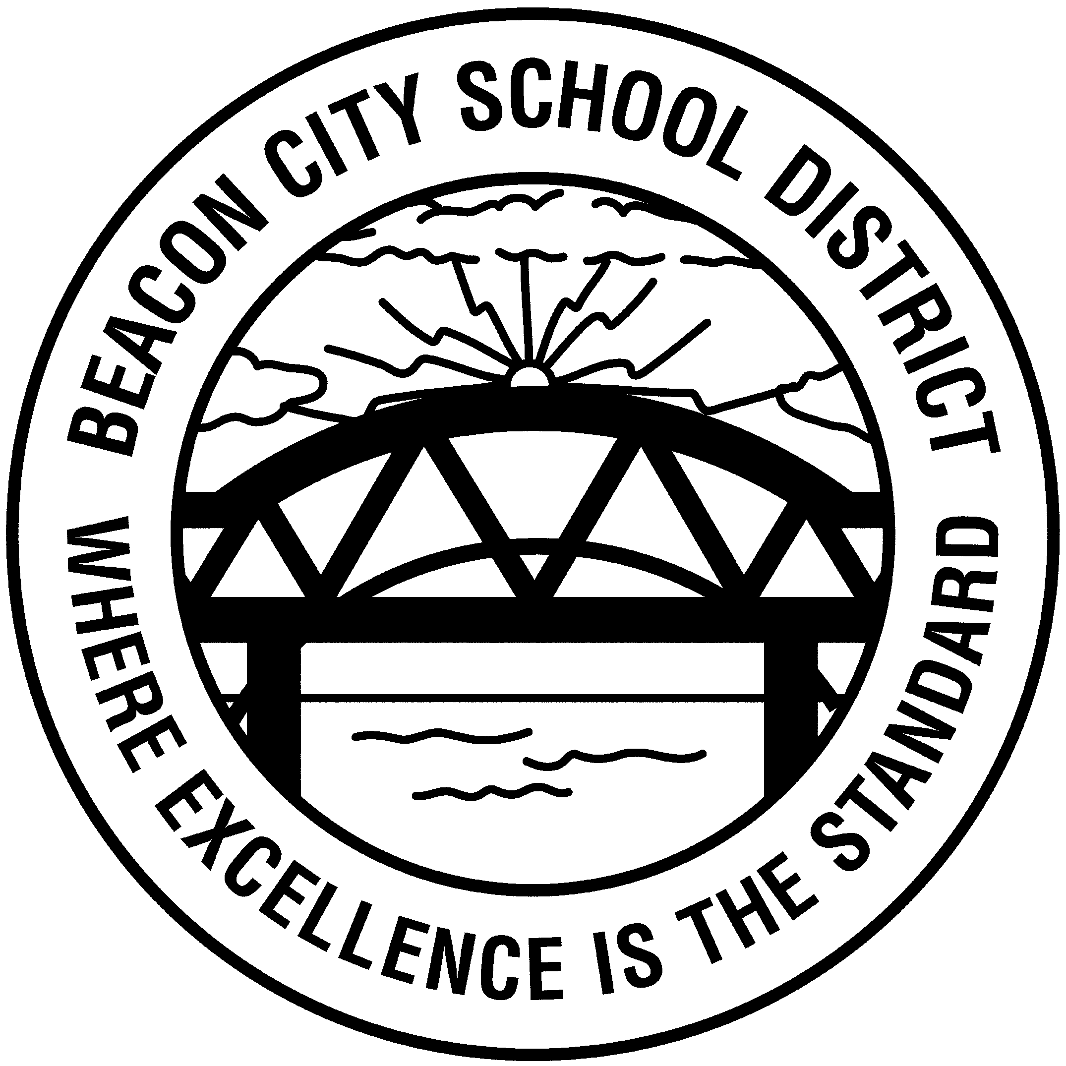
BEACON CITY SCHOOL DISTRICT

10 EDUCATION DRIVE
BEACON, NEW YORK 12508
PHONE 845-838-6900 ext 2701
FAX 845-838-6947

July 29, 2026

To parents/guardians of students attending private/parochial schools:

New York State Law requires that a written request (see Application for Private/Parochial Transportation Form) be made EACH YEAR for transportation to a non-public school. The parent or legal guardian must submit this request to the school district registrar office prior to April 1st of the upcoming school year. These forms have been provided to your child’s current school, and are also available on our district website. https://www.beaconk12.org/Transportation

Transportation may be provided by law for students who live within a distance of 15 miles. Students who live less than 1. miles from the school of attendance are not eligible for transportation.

For clarification purposes, whenever the district is on a weather-related delay or closing, all busing for the district follows that delay or closing for all schools, public and private. So if Beacon Schools are closed due to weather, there is no transportation to private/parochial schools or out of district special education.

The decision to close or delay is made primarily on what is safest for the students. When conditions are such that we do not feel it safe for buses to be picking up students within the district, these same conditions exist for both public and private school students residing within the district.

In terms of notification, the district notifies a great number of local media, including the following radio/television stations:

Pamal Broadcasting:
WHUD 100.7 FM www.whud.com
WSPK 104.7 FM www.k104online.com
WBNR 1260 AM & WLNA 1420AM www.hvradionet.com
WBPM 92.9 FM www.wbpmfm.com

Clear Channel Broadcasting:
WRWD 107.3 FM 1370 AM www.wrwdfm.com
WRNQ 92.1 FM www.921litefm.com
WBWZ 93.3 FM www.rock933fm.com

Postings are also on the District Website http://www.beaconcityk12.org/

If the private or special education school that your child attends is closed or delayed, they should be providing parents with this notification. Please check with your child’s school as to how they post closings/delays and/or notify parents. Please be sure to provide your child’s school with the most updated phone numbers. Calling the district transportation office to inquire about delays or closings is not the procedure to be followed. Please do not call the bus garage except in an emergency. They must keep the phone lines open for critical calls.

Sincerely,

Deborah Caul
Supervisor of Transportation
Beacon City School District

